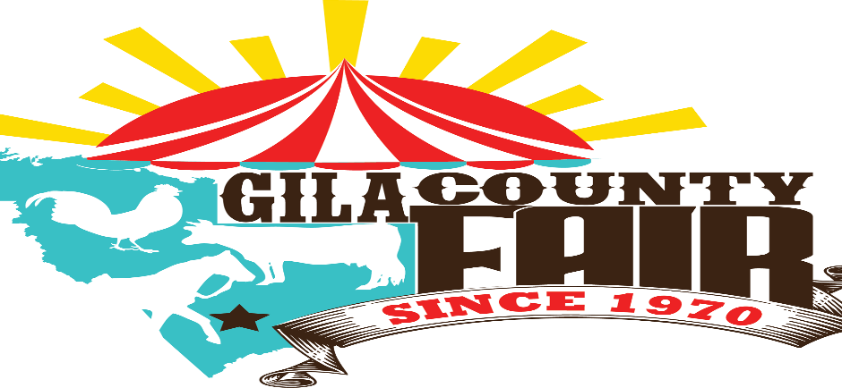

2024 MUD BOG RULES/INFORMATION

- SAFETY AND RUNNING RULES

- ALL PARTICIPANTS AND PASSENGERS MUST WEAR SEAT BELT, FULL FACE HELMET, GLOVES, AND EYE PROTECTION
- NO ALCOHOL ALLOWED BEFORE OR DURING THE EVENT
- NO FIGHTING
- ALL VEHICLES MUST HAVE A SECURE PULL POINT FOR ASSISTED REMOVAL IF NECCESARY
- VEHICLES WILL RUN ONE AT A TIME AND BE SCORED BY DISTANCE AND TIME.
- ALL PARTICIPANTS MUST BE 16 YEARS OF AGE TO COMPETE (EXCEPT POWER WHEELS)
- PARTICIPANTS UNDER 18 YEARS OF AGE MUST HAVE WAIVER SIGNED BY PARENT OR GUARDIAN

- FULL SIZE VEHICLES
- STREET / LIMITED
ANY PRODUCTION VEHICLE ALLOWED
SLIGHT BODY MODIFICATION ALLOWED
MAX 40” TIRES
ENGINE SWAPS ALLOWED
MUST BE NATURALLY ASPIRATED (NO SUPERCHARGERS OR TURBOS EXCEPT DIESEL)
ANY OPEN CABS MUST HAVE ROLL CAGE
NO NITROUS
- MODIFIED
ANY VEHICLE
ANY ENGINE
ANY TIRE SIZE
ANY OPEN CABS MUST HAVE ROLL CAGE
SUPERCHARGERS AND TURBOS ALLOWED
METHANOL ALLOWED (SFI APPROVED FIRE SUIT MUST BE WORN)
5 POINT HARNESS REQUIRED

- SIDE X SIDES
- ANY PRODUCTION SIDE X SIDE ALLOWED
- MODIFICATIONS ALLOWED
- ROLL CAGE MUST BE INTACT AND FUNCTIONAL
- SEAT BELTS MUST BE OPERABLE
- NO NITROUS
- METHANOL ALLOWED (SFI APPROVED FIRE SUIT MUST BE WORN)

- POWER WHEELS
- ANY PRODUCTION POWER WHEELS RIDE ON
- MODIFICATIONS ALLOWED
- MUST REMAIN ELECTRIC
- NO AFTERMARKET RUBBER TIRES, OEM WHEELS ONLY
- JR. CLASS 6 YEARS OLD AND UNDER
- SR. CLASS 7-12 YEARS OLD

- ENTRY FEES
- VEHICLE AND SIDE X SIDE ENTRY FEE $25.00, DOES NOT INCLUDE FAIR ENTRY
- POWER WHEELS ENTRY FEE $10.00 ,DOES NOT INCLUDE FAIR ENTRY
- PIT PASSES $10.00 DOES NOT INCLUDE FAIR ENTRY

- PAYOUTS
- STREET/LIMITED
  - 1ST PLACE $500
  - 2ND PLACE $250
  - 3RD PLACE $125
- MODIFIED
  - 1ST PLACE $500
  - 2ND PLACE $250
  - 3RD PLACE $125
- SIDE X SIDE
  - 1ST PLACE $500
  - 2ND PLACE $250
  - 3RD PLACE $125
- POWER WHEELS JR. AND SR.
  - 1ST PLACE $100
  - 2ND PLACE $50
  - 3RD PLACE $25
ANY QUESTIONS PLEASE CONTACT ANDY (928)812-1977 OR ENTERTAINMENT@GILACOUNTYFAIR.COM

